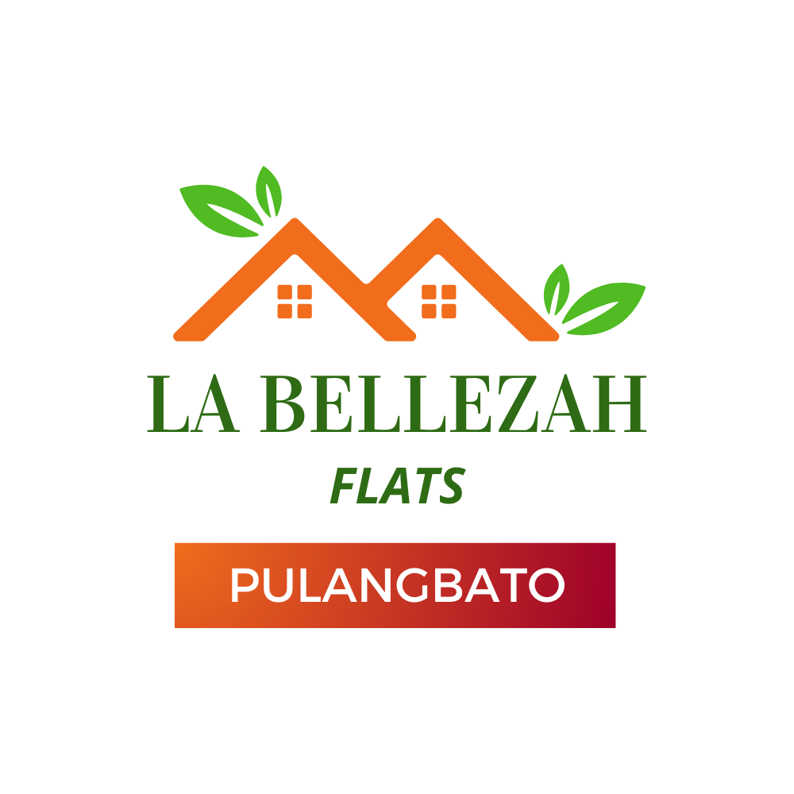

**LETTER OF INTENT**

Date:

**MYVAN PROPERTIES AND DEVELOPMENT, INC**.

2nd Floor, MYVAN Cityscape Tower Condominium

F. Cabahug St., Subangdaku, Mandaue City, Cebu 6014

To whom it may concern:

This is to voluntarily manifest my/our intent to acquire a unit:

Project Title: **La Bellezah Flats – Pulangbato**

Project Type: **Condominium**

Location: **Pulangbato, Cebu City**

* Studio Unit (**WITH** Balcony)
* Studio (**WITHOUT** Balcony)
* 1BR

Remarks: ____________________________________________

I fully understand that this letter does not represent, either express or implied, as an invitation, reservation or acceptance to reserve a unit. I was made to believe and submit that your office, momentarily, is neither offering nor accepting any reservation for a particular unit I’m intending to acquire.

As soon as the pricing schedule is made available and upon my consent, your office can automatically proceed with the processing of my reservation.

Should there be any measurement changes relative to floor and/or lot area I’m very much open for pro-active discussion.

For your reference, I truly submit herewith the following information:

| Full Name |  |
| --- | --- |
| Spouse’s Name (if married) |  |
| Address |  |
| Contact Nos. |  |
| Email Address |  |

I hereby name, appoint, and authorize _______________________ (Broker/Agent) with PRC Lic. No. _______________________ connected to _______________________________________ (Realty) as my true real estate service practitioner for this particular transaction until perfection of the sale with your company.

Your client,

_______________________________

Signature over Printed Name